**Chapter 5**

**MOBILE INFORMATION NOTIFIER FOR LA SALLE UNIVERSITY - OZAMIZ**

Mobile Information Notifier for LSU-Ozamiz is an Android application and a web-based system that is capable of creating and sending notifications to all the college students, some faculty and staff of La Salle University-Ozamiz. The web-based system is used by the Supreme Student Council, College, and some office secretaries while the Android application is utilized by the students and employees.

The way of disseminating any information is divided into three parts: all notification, office to college notification and vice versa, and college notification. Using the web-based system; the Supreme Student Council, College, and office secretaries can create and set the necessary information about the upcoming events that will be directly saved to the database. The data that has been saved to the database will then be automatically updated to the Android application in the form of pop-up notification, and that will make the dissemination of information fast and easy.

**System Objectives**

The study aims to develop an Android application and a web-based system that will help the information dissemination process in a fast and easy way.

It specifically aims to:

1. Notify the students and employees inside or outside the school campus whenever there are upcoming events.
2. Notify the students and employees ahead of time whenever there are upcoming events.
3. Develop a feature for the web-based system that can send notifications to colleges, offices and the SSC then vice versa.
4. Search previous notifications of the web-based system as well as the Android application.

**System Scope and Delimitation**

The system focuses on notifying every college, some major offices and most especially the college students at the LSU-Ozamiz. The system for the web can create a message that will be sent and posted in every college and some major offices page. Another is being able to view the previous and present notifications of the different colleges and some major offices. Moreover, for the mobile, the students and employees will receive notifications from the web-based system. The system will not cover other concerns except to the things that stated above.

**Physical Environment and Resources**

These are the system specifications used by the proponents in developing the research:

**Developer Side System/Application**

**Hardware**

**Platforms to be used:**

-RAM : 4.00 GB

-Hard Disk Drive : 1000 GB

-Processor : Intel CoreI5 1.70 GHz

-Laptop

-Mouse

**Software**

-OS : Windows 8.1 64 bit

-Platform : Laravel, Android Studio, Xampp

-Language : HTML, PHP, JAVASCRIPT, JAVA, MYSQL

**Deployment Specification**

**Recommended system requirements**

**Mobile Phone:**

**-**Mobile Phone OS : Android

-Version : API 9: Android 2.3 Gingerbread

-RAM : 512MB or higher

**Desktop Computer:**

-Computer OS : Windows 7 or later

-Processor : Intel CoreI3 or later

-RAM : 2GB or later

-Graphics Card : 2GB or later

**Peopleware**

The Supreme Student Council of LSU-Ozamiz, college, and office secretaries has authority to use the system in creating and sending notifications to the students and employees of La Salle University-Ozamiz.

**Use Case Modeling**

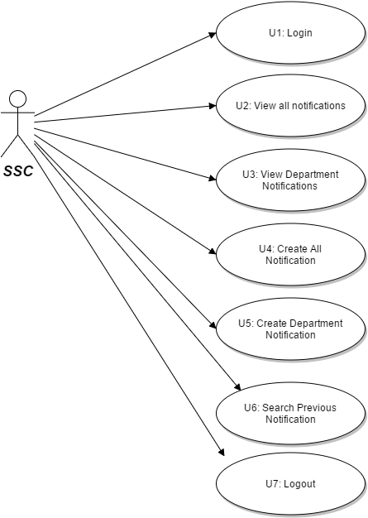

**Figure 3: Supreme Student Council Use Case Diagram**

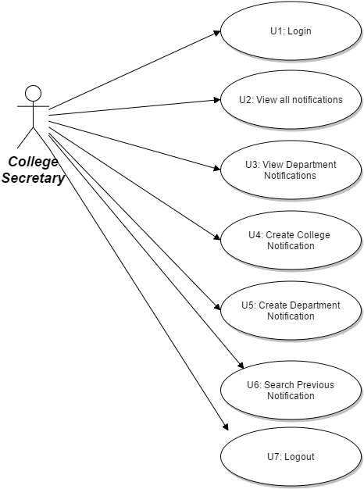

**Figure 4: College Secretary Use Case Diagram**

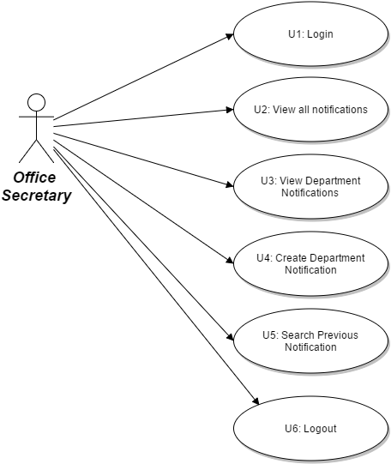

**Figure 5: Office Secretary Use Case Diagram**

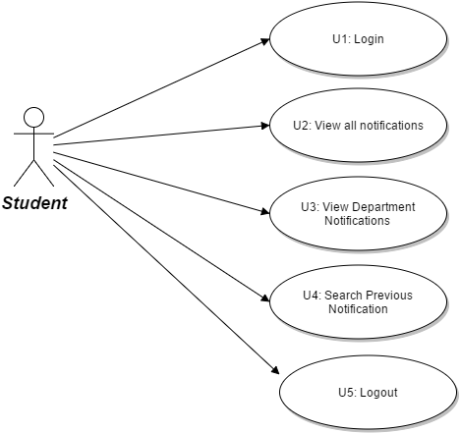

**Figure 6: Student Use Case Diagram**

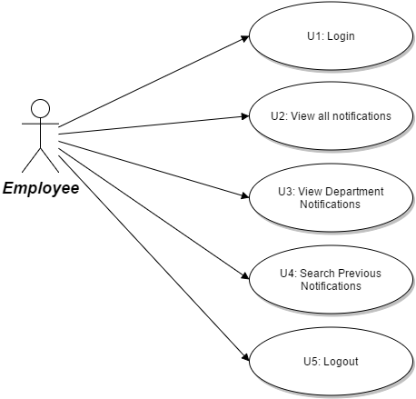

**Figure 7: Employee Use Case Diagram**

**Actor List**

1. **Supreme Student Council -** capable of creating the all notification and in charge of informing the students ahead of time about any upcoming school events. Able to view and create notifications for other colleges and offices.
2. **College Secretary -** the one in charge of creating notifications for its respective colleges. He/she can also receive and send notifications to other colleges, offices and also from the SSC.
3. **Office Secretary -** the one in charge of creating notifications for its respective offices. He/she can also receive and send notifications to other colleges, offices and also from the SSC.
4. **Student -** Can view all notifications and notifications from their respective colleges.
5. **Employee -** Can view all notifications and notifications from the offices.

**Supreme Student Council Use Case List**

**U1: Login –** The SSC must login his/her account first before using the web-based system.

**U2: View All Notification –** The SSC can view the latest events for the whole La Salle University College campus.

**U3: View Department Notification –** The SSC can also receive notifications from other colleges and some major offices in LSU-Ozamiz.

**U4: Create All Notification –** The SSC is responsible for notifying all the students, employees, colleges, and some major offices in LSU-Ozamiz.

**U5: Create Department Notification –** The SSC can also notify specific colleges and some major offices in LSU-Ozamiz.

**U6: Search Previous Notification –** Whenever they forgot some information about the previous events, the SSC can still find those previous notifications.

**U7: Logout -** allows the SSC to log out his/her account after using the web-based system.

**SSC Use Case Description**

**Table 1**

**LOGIN**

|  |  |
| --- | --- |
| U1: Login | |
| Pre-Condition: None | |
| Actor’s Action | System Response |
| 1. SSC enters user ID number and pin. | 1. The system checks if ID number and pin are provided. 2. The system will verify the ID number and pin if it is already valid. |
| Post-Condition: Home page appears | |
| Abnormal Path: If the user ID and pin is invalid, the system will ask to re-enter the user ID and pin. | |

**Table 2**

**VIEW ALL NOTIFICATION**

|  |  |
| --- | --- |
| U2: View All Notification | |
| Pre-Condition: SSC login successfully. | |
| Actor’s Action | System Response |
| 1. Clicks the body of the notification. | 1. The system will display the present to previous notifications (descending order).   3. Display the full content of the notification. |
| Post-Condition: none | |
| Abnormal Path: none | |

**Table 3**

**VIEW DEPARTMENT NOTIFICATION**

|  |  |
| --- | --- |
| U3: View Department Notification | |
| Pre-Condition: None | |
| Actor’s Action | System Response |
| 1. Clicks the body of the notification. | 1. Display the present to previous notifications of the department (descending order).   3. Display the full content of the notification. |
| Post-Condition: None | |
| Abnormal Path: None | |

**Table 4**

**CREATE ALL NOTIFICATION**

|  |  |
| --- | --- |
| U4: Create All Notification | |
| Pre-Condition: Complete information about a specific event. | |
| Actor’s Action | System Response |
| 1. Clicks the navigation tab for create all notification.   3. Fills up the form.  4. Set the proper date and receiver.  5. Clicks the send button. | 1. Display the create message form. 2. Save the new information to the database. 3. The system send the information to the receiver. |
| Post-Condition: Must successfully send the notification. | |
| Abnormal Path: None | |

**Table 5**

**CREATE DEPARTMENT NOTIFICATION**

|  |  |
| --- | --- |
| U5: Create Department Notification | |
| Pre-Condition: None | |
| Actor’s Action | System Response |
| 1. Clicks the navigation tab for create department notification.   3. Fills up the form.  4. Set the proper date and receiver.  5. Clicks the send button. | 1. Display the create message form.   6. Save the new information to the database.  7. The system will send the notification to the receiver. |
| Post-Condition: Must successfully send the notification. | |
| Abnormal Path: None | |

**Table 6**

**SEARCH PREVIOUS NOTIFICATIONS**

|  |  |
| --- | --- |
| U6: Search Previous Notifications | |
| Pre-Condition: None | |
| Actor’s Action | System Response |
| 1. Clicks the navigation tab for search previous notifications. 2. Input either the date or sender. | 1. Display the old notifications either all notification or department. |
| Post-Condition: None | |
| Abnormal Path: None | |

**Table 7**

**LOGOUT**

|  |  |
| --- | --- |
| U7: Logout | |
| Pre-Condition: After using the web based system. | |
| Actor’s Action | System Response |
| 1. Clicks the logout button. | 1. The system will log out the account of the SSC. |
| Post-Condition: Display the login form. | |
| Abnormal Path: None | |

**College Secretary Use Case List**

**U1: Login** – the college secretary must log in first before using web-based system.

**U2: View All Notification –** allows the college secretary to view all notification that he/she will receive from the SSC

**U3: View Department Notification –** allows the college secretary to see notifications from other colleges and some major offices.

**U4: Create College Notification –** allows the college secretary to notify his/her college whenever there are upcoming events.

**U5: Create Department Notification –** allows the college secretary to notify other colleges or offices about any upcoming events.

**U6: Search Previous Notification** – the college secretary can retrieve previous notifications from the database.

**U7: Logout -** allows the college secretary to log out his/her account after using the web-based system.

**Table 1**

**LOGIN**

|  |  |
| --- | --- |
| U1: Login | |
| Pre-Condition: The college secretary must have valid school account. | |
| Actor’s Action | System Response |
| 1. College secretary enter his/her ID number and pin. | 1. The system checks if ID number and pin are provided. 2. The system will verify the ID number   and pin if it is already valid. |
| Post-Condition: None | |
| Abnormal Path: Back to login form. | |

**Table 2**

**VIEW ALL NOTIFICATION**

|  |  |
| --- | --- |
| U2: View All Notification | |
| Pre-Condition: College secretary login successfully. | |
| Actor’s Action | System Response |
| 1. Clicks the navigation tab for view all notification.   3. Clicks the body of the notification. | 1. Display the present to previous notifications (descending order).   4. Display the full content of the notification. |
| Post-Condition: None | |
| Abnormal Path: None | |

**Table 3**

**VIEW DEPARTMENT NOTIFICATION**

|  |  |
| --- | --- |
| U3: View Department Notification | |
| Pre-Condition: None | |
| Actor’s Action | System Response |
| 1. Clicks the navigation tab for department notification.   3. Clicks the body of the notification. | 1. Display the present to previous notifications of the department (descending order).   4. Display the full content of the notification. |
| Post-Condition: None | |
| Abnormal Path: None | |

**Table 4**

**CREATE COLLEGE NOTIFICATION**

|  |  |
| --- | --- |
| U4: Create College Notification | |
| Pre-Condition: Complete information about a specific event. | |
| Actor’s Action | System Response |
| 1. Clicks the navigation tab for create college notification.   3. Fills up the form.  4. Sets the date and receiver  5. Clicks the send button. | 1. Display the message form. 2. Saves the information to the database. 3. The system will send the information to the receiver. |
| Post-Condition: Must successfully send the notification | |
| Abnormal Path: None | |

**Table 5**

**CREATE DEPARTMENT NOTIFICATION**

|  |  |
| --- | --- |
| U5: Create Department Notification | |
| Pre-Condition: Complete information about a specific event | |
| Actor’s Action | System Response |
| 1. Clicks the navigation tab for create department notification.   3. Fills up the form.  4. Set the proper date and its receiver.  5. Clicks the send button. | 1. Display the message form. 2. Save the information to the database. 3. The system will send the information to the receiver. |
| Post-Condition: Must successfully send the notification. | |
| Abnormal Path: None | |

**Table 6**

**SEARCH PREVIOUS NOTIFICATION**

|  |  |
| --- | --- |
| U6: Search Previous Notification | |
| Pre-Condition: None | |
| Actor’s Action | System Response |
| 1. Clicks the navigation tab for search previous notification. 2. Input either the date or sender. | 1. Display the old notifications either all notification or department. |
| Post-Condition: None | |
| Abnormal Path: None | |

**Table 7**

**LOGOUT**

|  |  |
| --- | --- |
| U7: Logout | |
| Pre-Condition: After using the web based system. | |
| Actor’s Action | System Response |
| 1. Clicks the logout button. | 2. The system will logout the account of the college secretary. |
| Post-Condition: Display the login form. | |
| Abnormal Path: None | |

**Office Secretary Use Case List**

**U1: Login –** the office secretary must input his/her valid ID number and PIN before using the web-based system.

**U2: View All Notification –** allows the office secretary to view all communications coming from the SSC.

**U3: View Department Notification –** allows the office secretary to view department notifications coming from other colleges and offices.

**U4: Create Department Notification –** allows the office secretary to notify other colleges and offices.

**U5: Search Previous Notification -** the office secretary can retrieve previous notifications from the database.

**U6: Logout –** allows the office secretary to log out after using the web-based system.

**Table 1**

**LOGIN**

|  |  |
| --- | --- |
| U1: Login | |
| Pre-Condition: The office secretary must have a valid school account. | |
| Actor’s Action | System Response |
| 1. Office secretary enters his/her ID number and pin. | 1. The system checks if the ID number and pin are provided. 2. The system will verify the ID number and pin if it is already valid. |
| Post-Condition: None | |
| Abnormal Path: Back to login form. | |

**Table 2**

**VIEW ALL NOTIFICATION**

|  |  |
| --- | --- |
| U2: View All Notification | |
| Pre-Condition: Office secretary login successfully. | |
| Actor’s Action | System Response |
| 2. Clicks the body of the notification. | 1. Display the present to previous notifications (descending order).   3. Display the full content of the notification. |
| Post-Condition: None | |
| Abnormal Path: None | |

**Table 3**

**VIEW DEPARTMENT NOTIFICATION**

|  |  |
| --- | --- |
| U3: View Department Notification | |
| Pre-Condition: None | |
| Actor’s Action | System Response |
| 1. Clicks the navigation tab for view department notification.   3. Clicks the body of the notification. | 1. Display the present to previous notifications of the department (descending order). 2. Display the full content of the notification. |
| Post-Condition: None | |
| Abnormal Path: None | |

**Table 4**

**CREATE DEPARTMENT NOTIFICATION**

|  |  |
| --- | --- |
| U4: Create Department Notification | |
| Pre-Condition: Complete information about a specific event. | |
| Actor’s Action | System Response |
| 1. Clicks the navigation tab for create department notification.   3. Fills up the form.  4. Set the proper date and its receiver.  5. Clicks the send button. | 1. Display the message form.   6. Save the information to the database.  7. The system will send the information to the receiver. |
| Post-Condition: Must successfully send the notification. | |
| Abnormal Path: None | |

**Table 5**

**SEARCH PREVIOUS NOTIFICATION**

|  |  |
| --- | --- |
| U5: Search Previous Notification | |
| Pre-Condition: None | |
| Actor’s Action | System Response |
| 1. Clicks the navigation tab for search previous notification. 2. Input either the date or sender. | 1. Display the old notifications either from all notification or department. |
| Post-Condition: None | |
| Abnormal Path: None | |

**Table 6**

**LOGOUT**

|  |  |
| --- | --- |
| U6: Logout | |
| Pre-Condition: After using the web based system. | |
| Actor’s Action | System Response |
| 1. Clicks the log out button. | 1. The system will log out the account of the office secretary. |
| Post-Condition: Display the login form. | |
| Abnormal Path: None | |

**Student Use Case List**

**U1: Login –** the student must input his/her valid ID number and PIN before he/she can use the android application.

**U2: View All Notification –** allows the student to view all notifications coming from the SSC.

**U3: View Department Notification –** allows the students to view department notifications coming from its respective colleges and some major offices.

**U4: Search Previous Notifications –** the student can retrieve previous notifications from the database.

**U5: Logout -** the student can log out after using the Android application.

**Table 1**

**LOGIN**

|  |  |
| --- | --- |
| U1: Login | |
| Pre-Condition: The student must have a valid school account. | |
| Actor’s Action | System Response |
| 1. Student enters ID number and pin. | 1. The system checks if the ID number and pin are provided. 2. The system will verify the ID number and pin if it is already registered. |
| Post-Condition: None | |
| Abnormal Path: Back to login form. | |

**Table 2**

**VIEW ALL NOTIFICATION**

|  |  |
| --- | --- |
| U2: View All Notification | |
| Pre-Condition: Student login successfully. | |
| Actor’s Action | System Response |
| 1. Clicks the navigation tab for view all notifications. 2. Clicks the long notification. | 1. Display the present to previous notifications (descending order). 2. Display the full content of the long notification. |
| Post-Condition: None | |
| Abnormal Path: None | |

**Table 3**

**VIEW DEPARTMENT NOTIFICATION**

|  |  |
| --- | --- |
| U3: View Department Notification | |
| Pre-Condition: None | |
| Actor’s Action | System Response |
| 1. Clicks the navigation tab for view department notification. 2. Clicks the long notification. | 1. Display the present to previous notifications of the department (descending order). |
| Post-Condition: None | |
| Abnormal Path: None | |

**Table 4**

**SEARCH PREVIOUS NOTIFICATIONS**

|  |  |
| --- | --- |
| U4: Search Previous Notifications | |
| Pre-Condition: None | |
| Actor’s Action | System Response |
| 1. Clicks the navigation tab for search previous notification. 2. Inputs either the date or sender. | 1. Display the old notifications either from all notifications or department notifications. |
| Post-Condition: | |
| Abnormal Path: | |

**Table 5**

**LOGOUT**

|  |  |
| --- | --- |
| U5: Logout | |
| Pre-Condition: None | |
| Actor’s Action   1. Clicks the log out button. | System Response   1. The system will log out the account of the student |
|  |  |
| Post-Condition: Display login form | |
| Abnormal Path: None | |

**Employee Use Case List**

**U1: Login -** the employee must input his/her valid ID number and PIN before he/she can use the mobile application.

**U2: View All Notification -** the employee can view all notifications coming from the SSC.

**U3: View Department Notification -** the employee can view college notifications and notifications from some major offices.

**U4: Search Previous Notifications –** allows the employee to retrieve previous notifications from the database.

**U5: Logout –** allows the employee to log out after using the android application

**Table 1**

**LOGIN**

|  |  |
| --- | --- |
| U1: Login | |
| Pre-Condition: The employee must have a valid school account. | |
| Actor’s Action | System Response |
| 1. Employee enters ID number and pin. | 1. The system checks if ID number and pin are provided. |
| Post-Condition: None | |
| Abnormal Path: Back to login form | |

**Table 2**

**VIEW ALL NOTIFICATION**

|  |  |
| --- | --- |
| U2: View All Notification | |
| Pre-Condition: Employee login successfully. | |
| Actor’s Action | System Response |
| 1. Clicks the navigation tab for view all notifications. 2. Clicks the long notification. | 1. Display the previous to present notifications (descending order). 2. Display the content of the long notification. |
| Post-Condition: None | |
| Abnormal Path: None | |

**Table 3**

**VIEW DEPARTMENT NOTIFICATION**

|  |  |
| --- | --- |
| U3: View Department Notification | |
| Pre-Condition: None | |
| Actor’s Action | System Response |
| 1. Clicks the navigation tab for view department notification. 2. Clicks the long notification. | 1. Display the previous to present notifications of the department (descending order). 2. Display the long notification. |
| Post-Condition: None | |
| Abnormal Path: None | |

**Table 4**

**SEARCH PREVIOUS NOTIFICATIONS**

|  |  |
| --- | --- |
| U4: Search Previous Notifications | |
| Pre-Condition: | |
| Actor’s Action | System Response |
| 1. Clicks the navigation tab for search previous notification. 2. Input either the date or sender. | 1. Display the old notifications either all notification or department notification. |
| Post-Condition: None | |
| Abnormal Path: None | |

**Table 5**

**LOGOUT**

|  |  |
| --- | --- |
| U5: Logout | |
| Pre-Condition: Done using the android application. | |
| Actor’s Action | System Response |
| 1. Clicks the log out button. | 1. The system will log out the account of the employee. |
| Post-Condition: Display the login form. | |
| Abnormal Path: None | |

**Class Diagram**

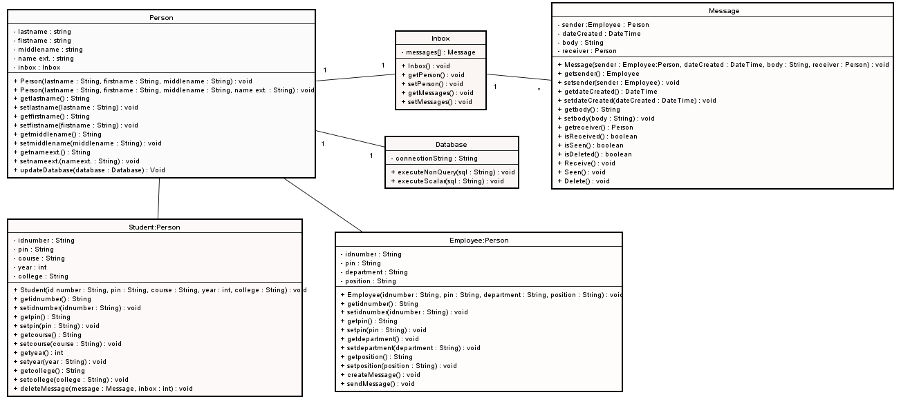

**Sequence Diagram for WEB**

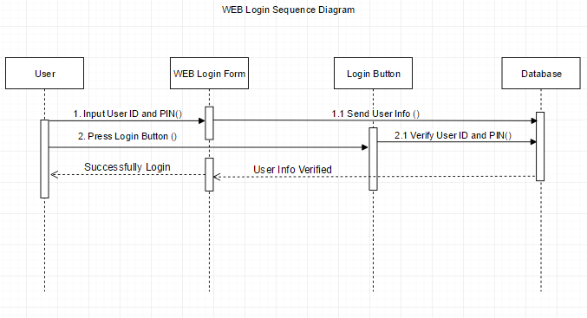

**Figure 1: Login Sequence Diagram**

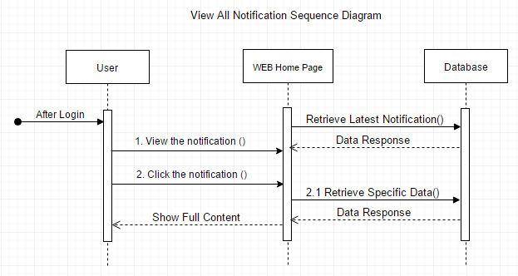

**Figure 2: View All Notification Sequence Diagram**

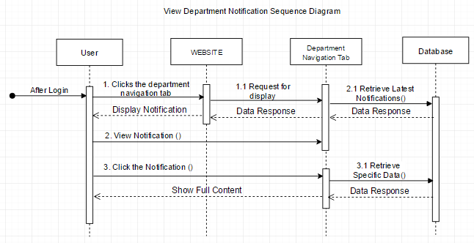

**Figure 3: View Department Notification Sequence Diagram**

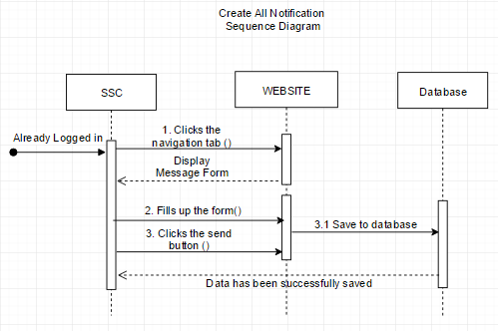

**Figure 4: Create All Notification Sequence Diagram**

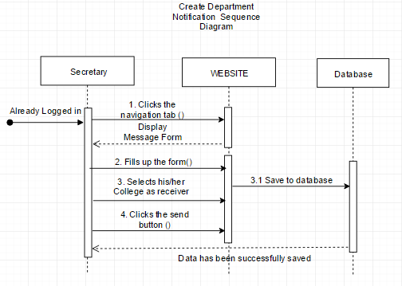

**Figure 5: Create College Notification Sequence Diagram**

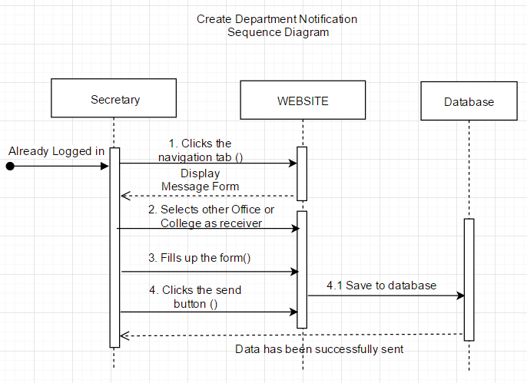

**Figure 6: Create Department Notification Sequence Diagram**

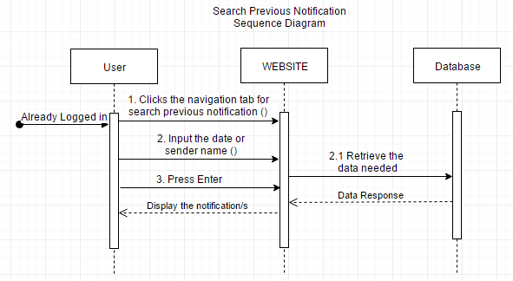

**Figure 7: Search Previous Notification Sequence Diagram**

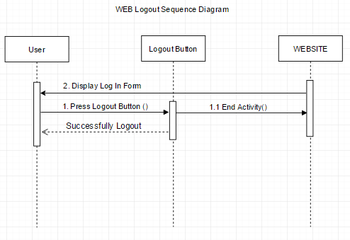

**Figure 8: Logout Sequence Diagram**

**Sequence Diagram for ANDROID**

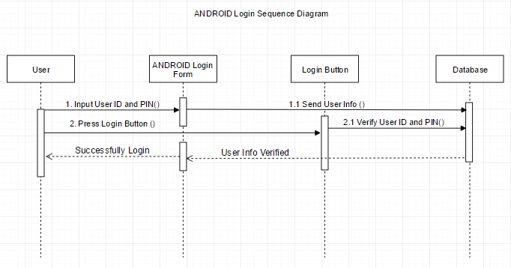

**Figure 9: Login Sequence Diagram**

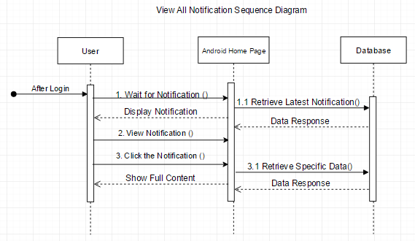

**Figure 10: View All Notification Sequence Diagram**

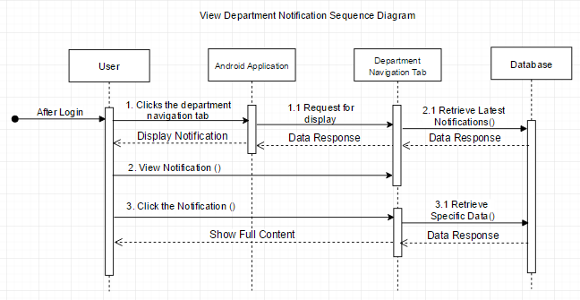

**Figure 11: View Department Sequence Diagram**

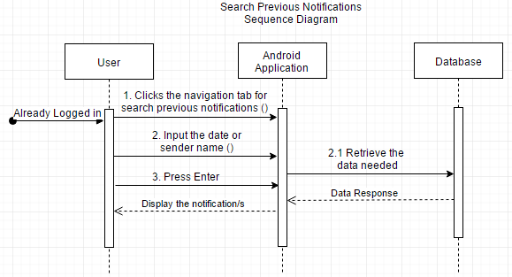

**Figure 12: Search Previous Notification Sequence Diagram**

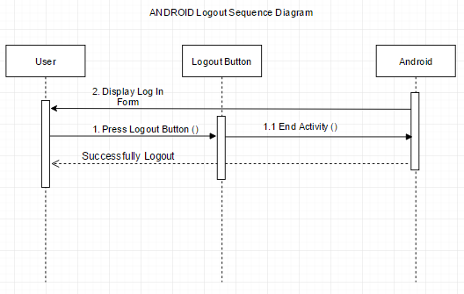

**Figure 13: Logout Sequence Diagram**

**Activity Diagram**



**Figure 1: Login Activity Diagram**



**Figure 2: View Department Notification Activity Diagram**



**Figure 3: View All Notification Activity Diagram**



**Figure 4: Create Department Notification Activity Diagram**



**Figure 5: Create All Department Notification Activity Diagram**



**Figure 6: Logout Activity Diagram**

**User Interfaces**

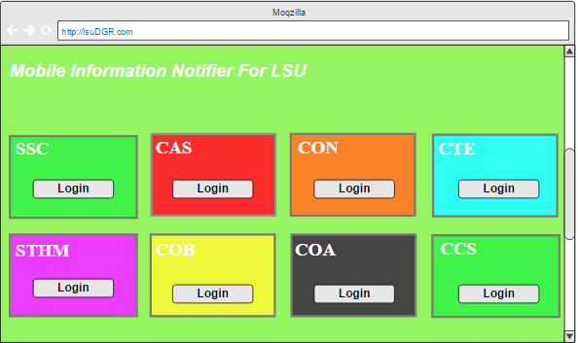

**Figure 7: WEB First Page**

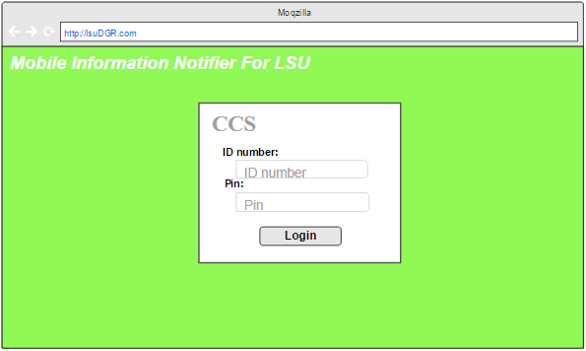

**Figure 8. WEB Login Page**

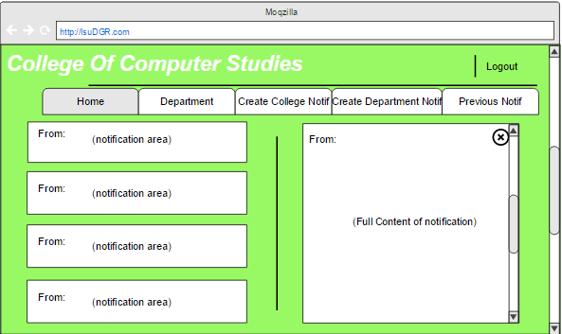

**Figure 9: WEB View All Notifications**

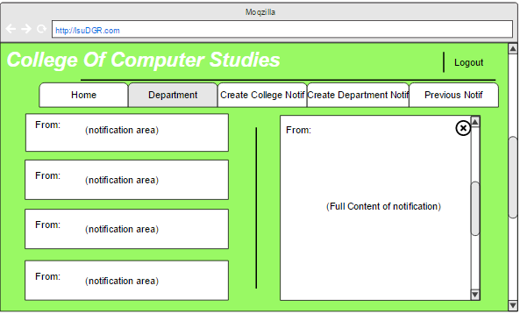

**Figure 10: WEB View Department Notifications**

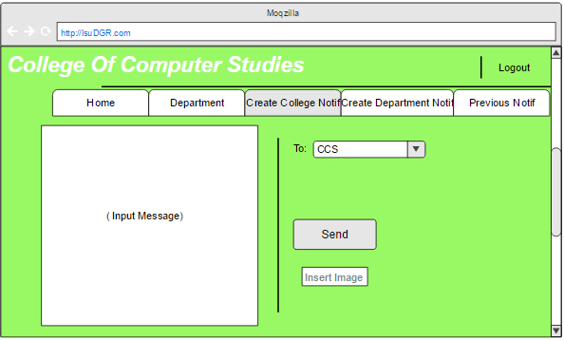

**Figure 11: WEB Create College Notification**

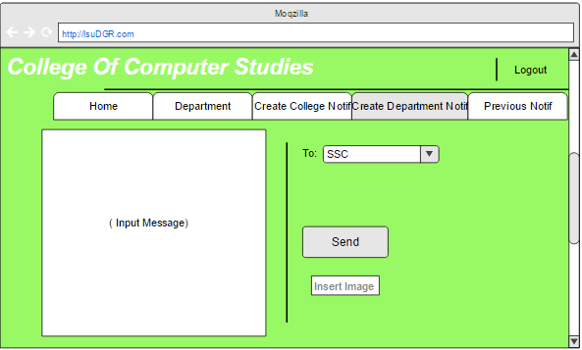

**Figure 12: WEB Create Department Notification**

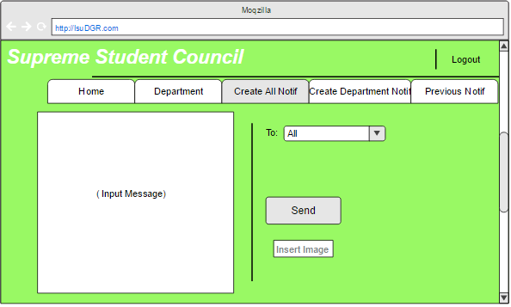

**Figure 13: WEB Create All Notification**

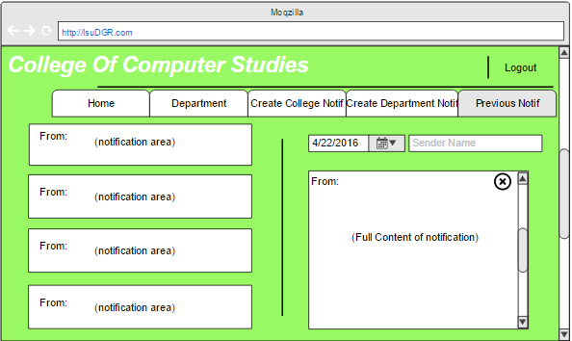

**Figure 14: WEB Search Previous Notification**

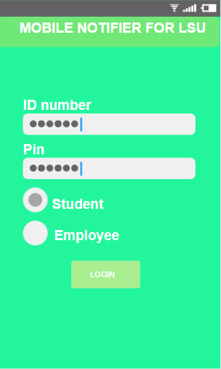

**Figure 15: ANDROID Login Page**

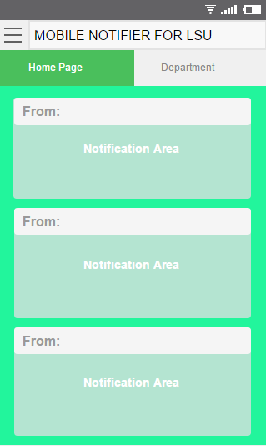

**Figure 16: ANDROID Home Page**

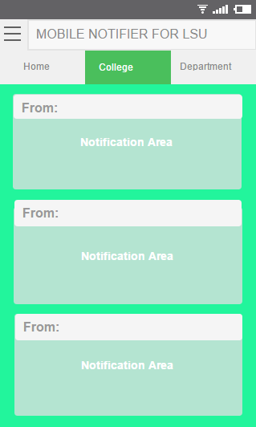

**Figure 17: ANDROID View College Notification**

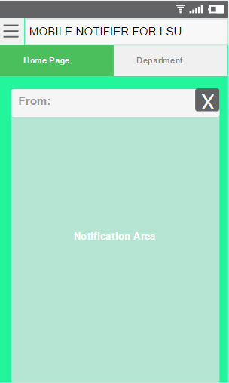

**Figure 18: ANDROID Show Full Content**

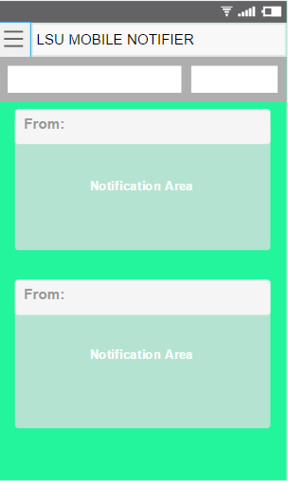

**Figure 19: ANDROID Search Previous Notification**

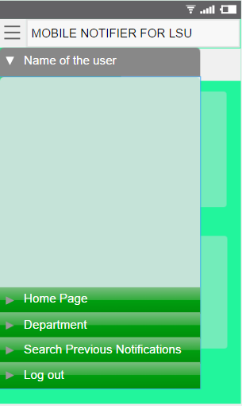

**Figure 20: ANDROID Navigation Tabs**